**1. Bugatti La Voiture Noire**



**Price: $18.7 million**

The Bugatti La Voiture Noire is the most expensive car in the world.

It’s a part of Bugatti’s plans to build two custom cars every year. Only one Noire will be built, and it’s pretty sexy… we think. Though first mentioned in 2019, Bugatti said it needed another 2 and a half years to finish building the car.

Boasting a top speed of 261mph, and 0-60mph in 2.5 seconds; that’s one hell of a rush.

Bugatti have states that an Anonymous buyer has purchased the car at the $18.7 million price tag, which is after tax. Pre-tax, the car is worth around $12.4 million USD.

**3. Rolls Royce Sweptail**

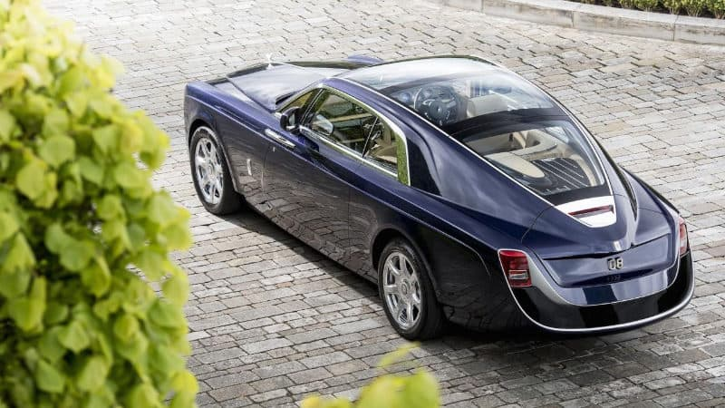

**Price: $13 Million**

Third place on our list of the most expensive cars is what can only be described as one stunning piece of handcrafted magic.

A powerhouse of automotive design and engineering, the Rolls-Royce Sweptail is a one-off luxury peace made in the United Kingdom by Rolls-Royce Motor Cars.

Commissioned in 2013 for a super-yacht and aircraft specialist, who’s identity Rolls-Royce does not divulge.

The Sweptail made its debut as the most expensive new car in the world at the yearly Concorso d’Eleganza Villa d’Este event in 2017.

It surpassed all its rivals and remains one of the most expensive cars ever sold.

**2. Pagani Zonda HP Barchetta**

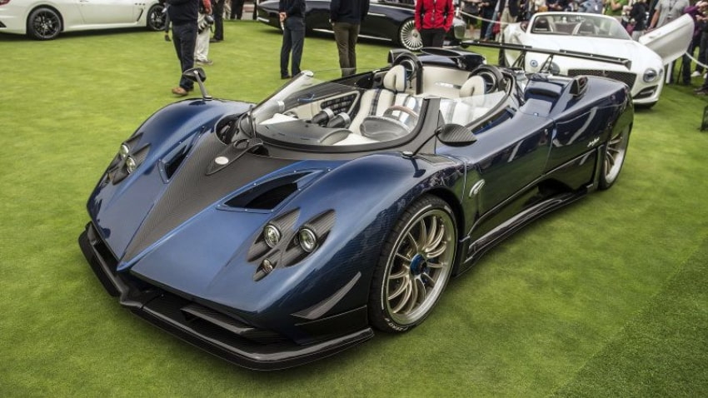

**Price: $17 Million**

The Pagani Zonda HP Barchetta is the second most expensive car in the world. It adds on to the already incredible legacy of the Pagani Zonda, and features a rather unique look. The rear wheels are partially covered by carbon fiber, the wind-shield is smaller than usual, and the car itself is roofless.

The Barchetta peaks at 789bhp with a top speed of 221mph. It is the fastest, and most powerful Zonda model ever produced.

It’s safe to say this car is a thing of beauty.

Although this is the second most expensive car on this list, it still has a ridiculous price tag of $17 million USD.

 <!DOCTYPE html>

<html>

<head>

<meta name="viewport" content="width=device-width, initial-scale=1">

<link rel="stylesheet" href="https://cdnjs.cloudflare.com/ajax/libs/font-awesome/4.7.0/css/font-awesome.min.css">

<style>

.fa {

padding: 20px;

font-size: 30px;

width: 50px;

text-align: center;

text-decoration: none;

margin: 5px 2px;

}

.fa:hover {

opacity: 0.7;

}

.fa-facebook {

background: #3B5998;

color: white;

}

.fa-twitter {

background: #55ACEE;

color: white;

}

.fa-google {

background: #dd4b39;

color: white;

}

.fa-linkedin {

background: #007bb5;

color: white;

}

.fa-youtube {

background: #bb0000;

color: white;

}

.fa-instagram {

background: #125688;

color: white;

}

.fa-pinterest {

background: #cb2027;

color: white;

}

.fa-snapchat-ghost {

background: #fffc00;

color: white;

text-shadow: -1px 0 black, 0 1px black, 1px 0 black, 0 -1px black;

}

.fa-skype {

background: #00aff0;

color: white;

}

.fa-android {

background: #a4c639;

color: white;

}

.fa-dribbble {

background: #ea4c89;

color: white;

}

.fa-vimeo {

background: #45bbff;

color: white;

}

.fa-tumblr {

background: #2c4762;

color: white;

}

.fa-vine {

background: #00b489;

color: white;

}

.fa-foursquare {

background: #45bbff;

color: white;

}

.fa-stumbleupon {

background: #eb4924;

color: white;

}

.fa-flickr {

background: #f40083;

color: white;

}

.fa-yahoo {

background: #430297;

color: white;

}

.fa-soundcloud {

background: #ff5500;

color: white;

}

.fa-reddit {

background: #ff5700;

color: white;

}

.fa-rss {

background: #ff6600;

color: white;

}

</style>

</head>

<body>

<h2>Style Social Media Buttons</h2>

<!-- Add font awesome icons -->

<a href="#" class="fa fa-facebook"></a>

<a href="#" class="fa fa-twitter"></a>

<a href="#" class="fa fa-google"></a>